Press release
26 January 2022

European milling contractors are affected by dramatic price increases for fuel and special tools

The removal of pavements in need of rehabilitation is carried out quickly and safely with high-quality special machines, the cold milling machines. This is why the work is usually carried out by special milling service providers who work as subcontractors of the construction companies. The VESF e.V. (Association of European Road Milling Contractors) points out that milling contractors are currently under enormous economic pressure. The reason is the noticeable increase in raw material prices: In addition to the well-known rising cost of diesel fuel, rising prices for special tools, so-called cutting tools, are also burdening the companies.

The lion's share of the increase in operating costs is caused by the continuing skyrocketing of diesel prices – and this despite the fact that companies have been investing in more economical technology for years. In addition, there is a cost increase for the highly temperature-resistant and wear-resistant special tools, which is 3-4 times the inflation rate in the EU. Depending on the type of machine and site requirements, between 50 and 1,000 cutting tools are installed in a machine. They usually have to be replaced several times a week.

General increases in safety requirements, higher wages and purchase prices also contribute to the rise in costs. At the end of the day, the VESF has recorded an increase in costs of around 15 - 18 % at the beginning of 2022 compared to the average prices from 2019. In relation to the various machine classes, the milling association puts the price increases at around 15 % for small and compact milling machines. For large milling machines, the increase is even higher at almost 18% due to the necessary high engine outputs and the associated fuel consumption. "Unfortunately, due to this development, we have to pass on the cost increases to our clients," Torsten Meyer, 1st Chairman of the VESF, regrets this situation. However, he hopes for the understanding of the customers: "We have to take this step in order to be able to carry out the milling work in the usual quality and at the usual high speed also in the future."

Contact:
VESF e.V.
Verband Europäischer Straßenfräsunternehmungen e.V.
Ringstraße 21
56651 Niederdürenbach
Germany

Web: www.vesf-ev.com
Phone: +49 2636 9419 118

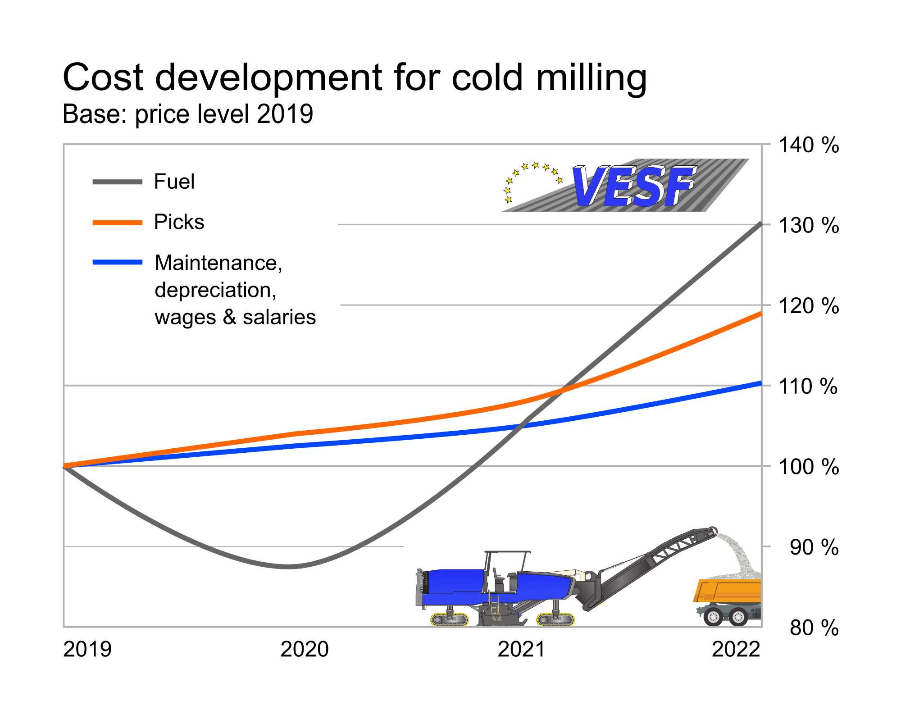

VESF points to the sharp increase in operating costs.
The effects are particularly noticeable for large milling machines.

